The objective is to raise revenue for Big Mountain Resort. The model will demonstrate that one way to do this is to raise the ticket price which is currently at charging $81.00 for the Adult Weekday and Adult Weekend tickets. We designed our new ticket price model based on the Adult Weekend price, even though the price is the same for Big Mountain Resort that is not the case for the competitors. We looked at data from various ski resorts and states across the United States of America. Our model showed that there are 8 key features which have a high correlation with the ticket price (see chart below)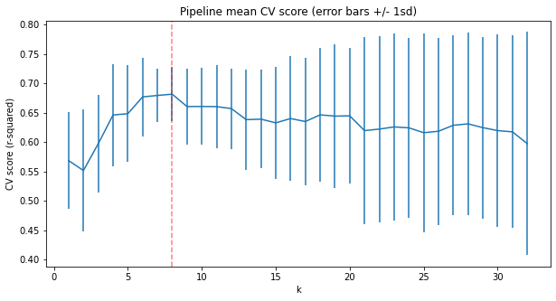

These features are vertical_drop, Snow Making_ac, total_chairs, fastQuads, Runs, LongestRun_mi, trams, SkiableTerrain_ac.

The model predicted a price of $95.87 per ticket with an error margin of $10.39. This is fair price based on comparative features without any changes to features being made.

Big Mountain Resort can also take other measures to increase revenue. Big Mountain Resort can cut cost by closing 1 run without having an effect on ticket prices. However, closing more than 1 correlates to a lower ticket price. If Big Mountain Resort where to add 1 run and increase the vertical drop by 150 feet the ticket price can be raised by an additional $1.99, adding 2 acres of snow making will make no difference. Additionally, increasing the longest run by .2 miles and adding 4 acres of snow also makes no difference.